**AGRICULTURAL CROP RECOMMENDATIONS BASED ON**

**PRODUCTIVITY AND SEASON**

1 Mrs. S. S. RAJA KUMARI, 2 NAGI REDDY GARI BHARATH KUMAR REDDY, 3 MUNUMANDINNE SURYA PRAKASH, 4 KURUVA MAHENDRA, 5 BEERAM KUSHINATHREDDY

Dept of CSE, St. Johns College of Engineering and Technology, Yerrakota Yemmiganur, Kurnool, AP, Affiliated by JNTUA, INDIA

1 M.tech,(Ph.D), Associate Professor in CSE Department,[ssrajakumari2009@gmail.com](mailto:ssrajakumari2009@gmail.com)

2 [bharathkumarreddybharath055@gmail.com](mailto:bharathkumarreddybharath055@gmail.com), 3 [munumandinnesurya@gmail.com](mailto:munumandinnesurya@gmail.com), 4 [mahendrakmr540@gmail.com](mailto:mahendrakmr540@gmail.com), 5 [kushibeeram@gmail.com](mailto:kushibeeram@gmail.com)

**Abstract:** As a coastal state, Tamil Nadu faces uncertainty in agriculture which decreases its production. With more population and area, more productivity should be achieved but it cannot be reached. Farmers have words-of-mouth in past decades but now it cannot be used due to climatic factors. Agricultural factors and parameters make the data to get insights about the Agri-facts. Growth of IT world drives some highlights in Agriculture Sciences to help farmers with good agricultural information. Intelligence of applying modern technological methods in the field of agriculture is desirable in this current scenario. Machine Learning Techniques develops a well-defined model with the data and helps us to attain predictions. Agricultural issues like crop prediction, rotation, water requirement, fertilizer requirement and protection can be solved. Due to the variable climatic factors of the environment, there is a necessity to have a efficient technique to facilitate the crop cultivation and to lend a hand to the farmers in their production and management. This may help upcoming agriculturalists to have a better agriculture. A system of recommendations can be provided to a farmer to help them in crop cultivation with the help of data mining. To implement such an approach, crops are recommended based on its climatic factors and quantity. Data Analytics paves a way to evolve useful extraction from agricultural database. Crop Dataset has been analyzed and recommendation of crops is done based on productivity and season.

**1. INTRODUCTION**

The agriculture sector is one of the most important sectors in many countries. The agriculture sector provides food, raw material, and employment. The agriculture sector faces many problems such as irregular rainfall, floods, drought, climate change, etc. To overcome these problems technological solution is needed which can help the farmers. The productivity of farming is not only depending on natural resources, but it also depends on input provided to the system such as type of soil, type of fertilizer, and crops. These inputs can increase or decrease the productivity of any crop. old age crop selection is not precise and does not have any analysis details. To surmount such quandaries data mining and machine learning techniques can be utilized. In the agriculture sector data set for a long time duration is available. Data mining is used to analyze the dataset and extract information from it. Machine Learning algorithms can be used to predict the proper crop so that it will lead to less loss in inputs and increases the overall profit. We live in a country whose 60% of the population is directly involved in agriculture the potentiating them would potentiate the nation’s magnification. Cultivating a crop is not everyone’s cup of tea, as it is a very tedious task and requires constant attention towards crop, due to incongruous utilization of pesticides and other prominent reasons crop suffer sundry diseases that need a timely and precise diagnosis of diseases. It is crucial to obviate nonessential waste of financial and other resources, thus achieving more salubrious engenderment in this transmuting environment. Congruous and timely disease identification including early aversion has never been more paramount. There are several ways to detect plant pathologies. Some diseases do not have any visible symptoms, or the effect becomes conspicuous too tardy to act, and in those situations, a sophisticated analysis is obligatory. However,

most diseases engender manifestation within the color spectrum, therefore the unclad ocular perceiver examination of a trained professional is that the prime technique adopted in practice for disease detection. so as to realize precise diagnostics, a plant pathologist should possess good optical discernment skills so that one can identify characteristic symptoms. Variations in symptoms betokened by diseased plants may lead to an incongruous diagnosis since tyro gardeners and hobbyists could have more difficulties determining it than a professional plant pathologist. A Machine Learning System is required to avail identify plant diseases by the plant’s appearance and visual symptoms could be of great avail to abecedarians in the farming process. Advances in computer vision present an opportunity to expand and enhance the practice of precise plant bulwark and elongate the market of computer vision applications in the field of precision agriculture. Exploiting prevalent digital image processing techniques such as color analysis and thresholding was utilized with the aim of detection and relegation of plant diseases. According to disease, a remedy is suggested to remedy that disease.

**2. LITERATURE SURVEY**

The framework in paper [1] recommended by creators S. Pudumalar and related co-creators utilizes a gathering system called Majority Voting Technique which consolidates the intensity of numerous models to accomplish more prominent forecasts precision. The strategies utilized are Random Trees, KNN, CHAID and Naïve Bayes for gathering so that regardless of whether one strategy predicts erroneously, alternate models are probably going to make the right forecasts and since the greater part casting a ballot system is utilized, the last expectation is the right one. On the off chance that rules are the fundamental segments that are utilized in the expectation procedure. The exactness got is 88% utilizing the gathering model. Paper [2] is an audit paper to concentrate on different calculations and their exactness in the rural field proposed by Yogesh Gandge and Sandhya. It was seen that Multiple Linear Regression gave a precision of 90-95% for rice yield. Choice tree utilizing ID3 calculation was considered for soybean edit and the proposals were created. The third calculation was SVM which was utilized on every one of the harvests and the precision was great with computationally fewer prerequisites. The neural system was utilized on corn information to accomplish 95% of precision. Different calculations were additionally utilized which are KNN, C4.5, K-implies, J48, LAD Tree and Naïve Bayes. The end was that still enhancement is required for the calculations to accomplish better precision. Being used as Data Mining in Crop Yield Prediction [3], paper [3], the dataset utilized was gathered from Kaggle.com The creator has broken down the information utilizing the WEKA apparatus for calculations which are LWL, J48, LAD Tree and IBK. The exactness was estimated utilizing explicitness, affectability, precision, RMSE and mean outright blunder. For every classifier, the perplexity network was utilized to get the effectively distinguished occurrences. The perception was that better precision can be acquired if pruning is utilized. Paper [4] displayed by Rakesh Kumar, M.P. Singh, Prabhat Kumar, and J.P. Singh proposed utilization of seven machine learning methods, for example, ANN, SVM, KNN, Decision Tree, Random Forest, GBDT and Regularized Gradient Forest for crop choice. The framework is intended to recover every one of the yields sowed and time of developing at a specific time. The yield rate of each harvest is acquired and the crops giving higher yields are chosen. The framework additionally proposes an arrangement of crops to be planted to get higher yields. Prof. Rakesh Shirsathand other co-creator in paper [5] proposed a framework that causes the clients to settle on choices for the crop to be planted. The framework utilized is a membership-based framework which would have customized data of each rancher enlisted. The framework incorporates a module that keeps up the data of the past harvests planted gathered from different sources and demonstrates a coordinating crop that can be planted. The entire procedure is finished with the assistance of fake impartial systems. Toward the end, a criticism framework is given with the goal that the designer can make changes required if the rancher discovers some trouble while utilizing the framework. Enormous Data Analysis Technology Application in Agricultural Intelligence Decision System paper creators Jinchuan Zhao and Jian-Xin Guo in paper [6] considers the information database as large information and derivations from the information is drawn. It considers different modules like clients, information build, area master, manmachine interface, deduction motor, and learning base. The learning procurement framework gets information for the choice framework and sets up a powerful learning base to take care of the issue.

**3. METHODOLOGY**

Our product is a recommender system that recommends the congruous crop and detects plant disease to the farmers. Rudimentary, the project divides into multiple modules.

1. **About Dataset:**

Our Dataset for the Crop Recommender System comprises five most prominent factors of soil for production i.e Nitrogen, Phosphorus, Potassium, Organic Carbon, Ph Value. Nitrogen is responsible for the development of proteins in the plant, phosphorus is responsible for the plant’s ability to store energy, potassium takes care of plant’s resistance to disease, Organic Carbon takes care of plant’s stability and aeration capacity. All these features vary according to different crops and different region’s soil formation. Data is collected from the Government Website for Soil Health Card. Dataset of Plant disease is collected from Github which comprise of image pixels as a feature set to train model in detecting disease form image sample.

1. **OCR Module (Deep Learning):**

The first module is just a simple User Interface. This User interface is engendered with the avail of python flask. Through this Utilizer Interface, farmers upload their Soil Health Card image and our OCR module works to extract data from the soil health card like the values of Nitrogen, Phosphorous, Potassium, Carbon Oxide Percentage, pH and store them as a test feature set for our model. Data is extracted using Google Tesseract-OCR Engine which uses Convolutional Neural Network to extract text, a number from the image.

1. **Crop Recommender Module (Machine Learning):**

In this Module, we utilized the soil health card dataset to train our model on different features like nitrogen, phosphorous, potassium, carbon oxide, pH value, and the crop name as a label. Here Rudimentary we have used Neural Network to prognosticate the all best felicitous crops for farmers. In relegation, we find the probability of each class and show those crops whose probability is more preponderant than the mean of the probability of all classes and show them as output. The network comprises 2 hidden layers where Relu (Rectified Linear Unit) function is used as the activation function for hidden layers neuron and at output layer Sigmoid function is used to get a normal probability distribution of crops.

1. **Plant Disease Detector:**

In this module, we have trained our model using a plant disease dataset which comprises image pixel set as features to evaluate. The model consists of 6 convolutional layers where Inverse Dropout is used to Regularize the model at the output layer Sigmoid function is used to get a normal probabilistic distribution to identify the disease from a list of disease. Through this not only we detect the disease but also recommend an organic solution to the problem.

**4. EXPERIMENTAL RESULTS**

**INPUT DESIGN**

The input design is the link between the information system and the user. It comprises the developing specification and procedures for data preparation and those steps are necessary to put transaction data in to a usable form for processing can be achieved by inspecting the computer to read data from a written or printed document or it can occur by having people keying the data directly into the system. The design of input focuses on controlling the amount of input required, controlling the errors, avoiding delay, avoiding extra steps and keeping the process simple. The input is designed in such a way so that it provides security and ease of use with retaining the privacy. Input Design considered the following things:

* What data should be given as input?
* How the data should be arranged or coded?
* The dialog to guide the operating personnel in providing input.
* Methods for preparing input validations and steps to follow when error occur.

**OBJECTIVES**

1.Input Design is the process of converting a user-oriented description of the input into a computer-based system. This design is important to avoid errors in the data input process and show the correct direction to the management for getting correct information from the computerized system.

2. It is achieved by creating user-friendly screens for the data entry to handle large volume of data. The goal of designing input is to make data entry easier and to be free from errors. The data entry screen is designed in such a way that all the data manipulates can be performed. It also provides record viewing facilities.

3.When the data is entered it will check for its validity. Data can be entered with the help of screens. Appropriate messages are provided as when needed so that the user will not be in maize of instant. Thus the objective of input design is to create an input layout that is easy to follow

**OUTPUT DESIGN**

A quality output is one, which meets the requirements of the end user and presents the information clearly. In any system results of processing are communicated to the users and to other system through outputs. In output design it is determined how the information is to be displaced for immediate need and also the hard copy output. It is the most important and direct source information to the user. Efficient and intelligent output design improves the system’s relationship to help user decision-making.

1. Designing computer output should proceed in an organized, well thought out manner; the right output must be developed while ensuring that each output element is designed so that people will find the system can use easily and effectively. When analysis design computer output, they should Identify the specific output that is needed to meet the requirements.

2.Select methods for presenting information.

3.Create document, report, or other formats that contain information produced by the system.

The output form of an information system should accomplish one or more of the following objectives.

* Convey information about past activities, current status or projections of the
* Future.
* Signal important events, opportunities, problems, or warnings.
* Trigger an action.

Confirm an action.



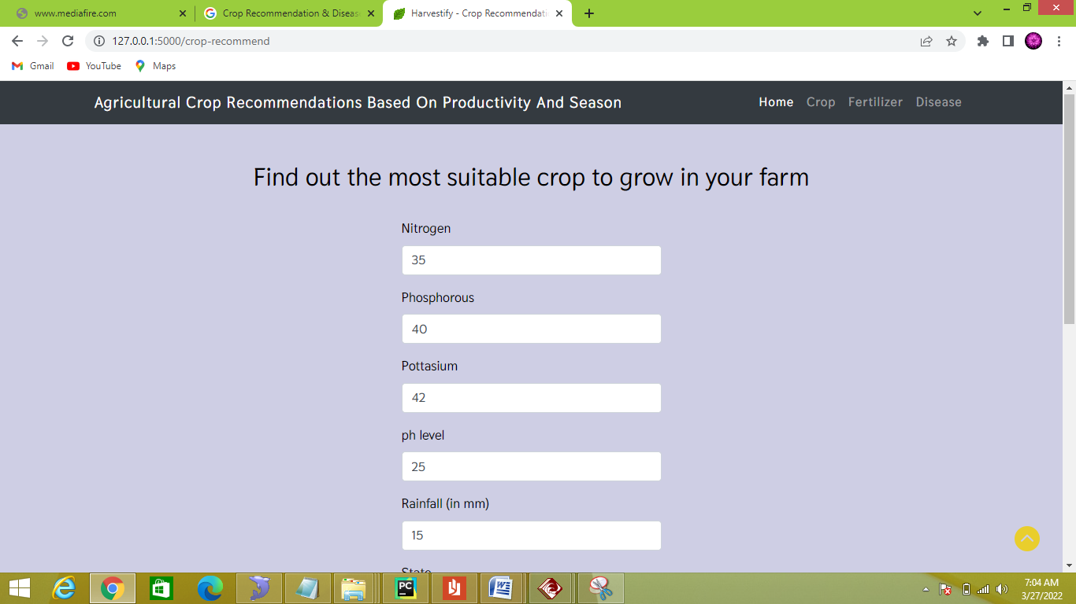

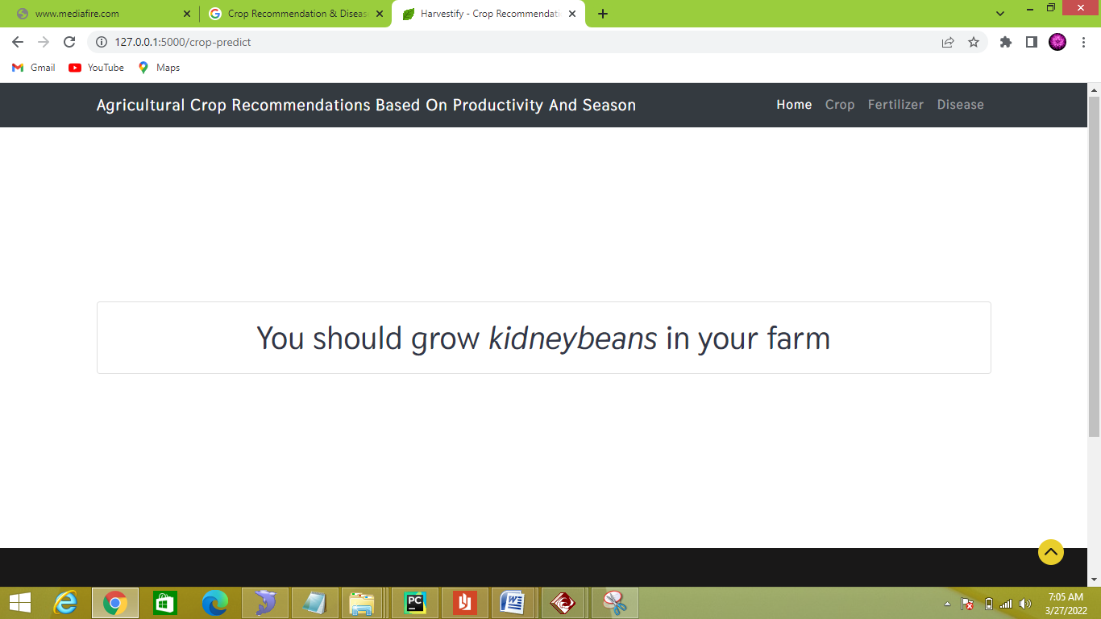

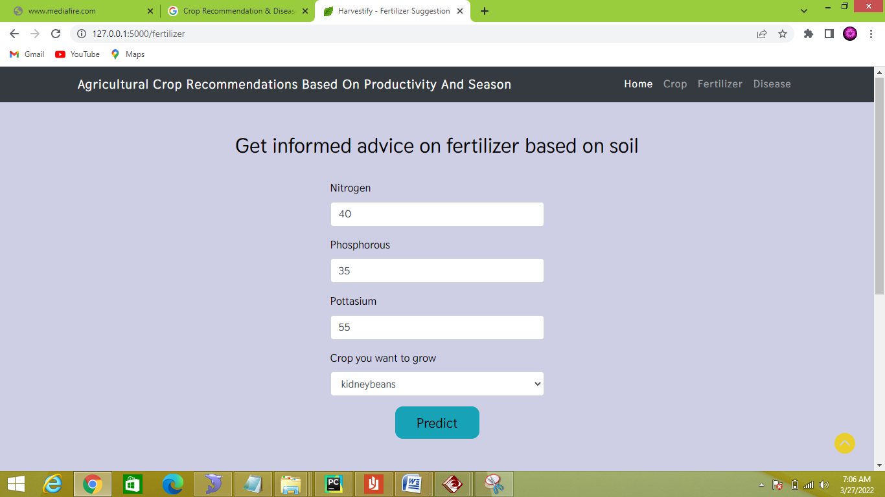

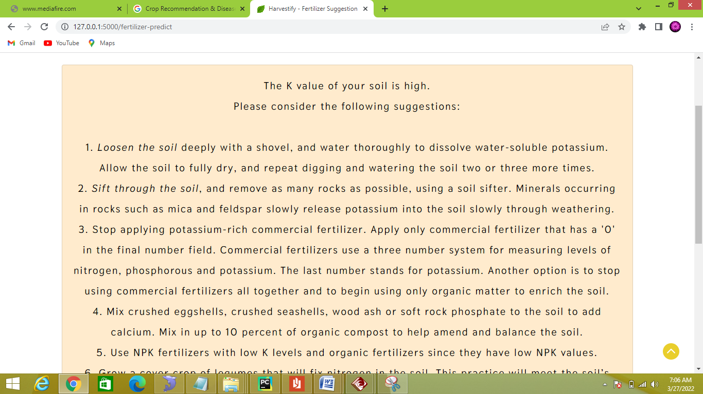

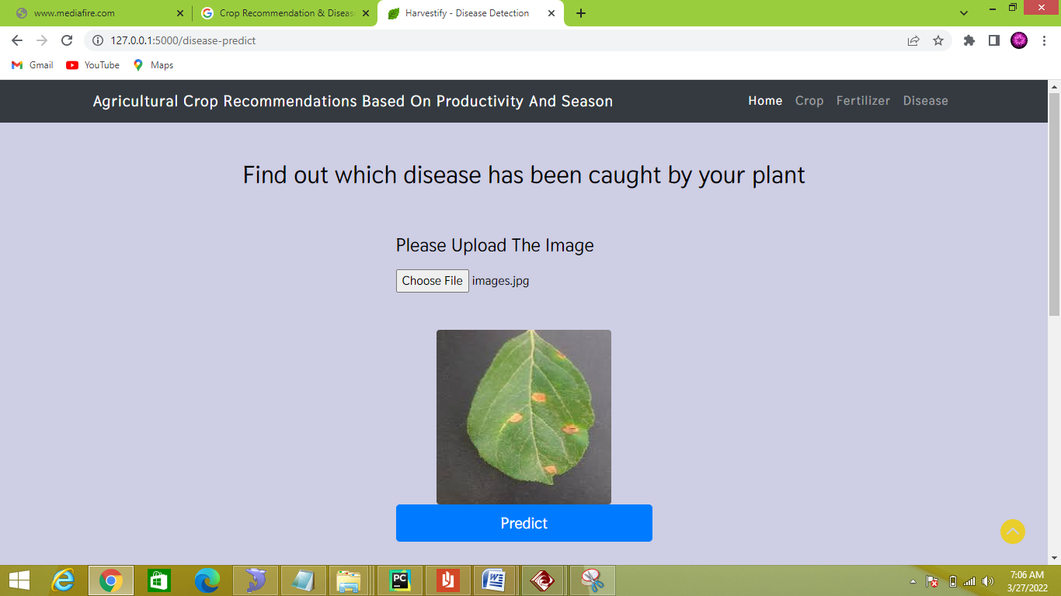

**5. CONCLUSION**

Nowadays farmers facing lots of problems in the agricultural field due the crop production and they don’t know the proper information regarding how to improve crop production for what they invest and also to cultivate. This proposed system helps the farmers to know about what is a right crop to grow in that field. Proposed system predicts the crops using various data mining techniques aspecially using a Naïve Bayesain algorithm to get accurate results. This system also useful to agricultural departments to predict the right crop in right time which gives the efficient results. If we have such kind of an automation, then it will be useful to farmers and agricultural field. The goals that have been achieved by the developed system are, Simplified and reduce the manual work of the agricultural department, Large volumes of data can be stored and It provides Smooth work flow. . In the prosperity of the farmers, prospers the nation. Thus our work would avail farmers in sowing the right seed predicated on soil requisites to increase productivity and acquire profit out of such a technique. Thus the farmers can plant the right crop incrementing his yield and withal incrementing the overall productivity of the nation.

**6. FUTURE SCOPE**

It can be implemented in all the cities.

− Multilingual Communication.

− Increase scope to all crops

− Remove dependency on labs

− Provide Farmer a genuine-time market rate of crops.

**7. REFERENCES**

1. A. Nigam, S. Garg, A. Agrawal, & P. Agrawal, “Crop Yield Prediction Using Machine Learning Algorithms”, In 2019 Fifth International Conference on Image Information Processing (ICIIP), IEEE , pp. 125-130, November 2019.

2. T. van Klompenburg, A. Kassahun, & C. Catal, “Crop yield prediction using machine learning: A systematic literature review”, Computers and Electronics in Agriculture, vol. 177, p. 105709, October 2020.

3. R. A. Medar, & V. S. Rajpurohit, “A survey on data mining techniques for crop yield prediction”, International Journal of Advance Research in Computer Science and Management Studies, vol. 2, no. 9, pp. 59-64, September 2014.

4. A. J. Challinor, J. M. Slingo, T. R. Wheeler, & F. J. Doblas-Reyes, “Probabilistic simulations of crop yield over western India using the DEMETER seasonal hindcast ensembles”, Tellus A: Dynamic Meteorology and Oceanography, vol. 57, no. 3, pp. 498-512, January 2005.

5. A. Ceglar, and L. Kajfež-Bogataj, "Simulation of maize yield in current and changed climatic conditions: addressing modelling uncertainties and the importance of bias correction in climate model simulations", European Journal of agronomy, vol. 37, no. 1, pp. 83-95, February 2012.

6. (Open Source Article) “A complete guide to the random forest algorithm”, Built In, Available: <https://builtin.com/data-science/random-forest-algorithm>

7. (Open Source Article) “Understanding Gradient Boosting Machines”, Available: https://towardsdatasecience.com/understanding-gradient-boosting-mac hines-9be756fe76ab

8. (Open Source Article) “An intuitive guide to Gaussian processes”, Medium, Available: https://towardsdatascience.com/an-intuitive-guide-to-gaussian-process es-ec2f0b45c71d

9. P. Vidyullatha, & D. R. Rao, “Machine learning techniques on multidimensional curve fitting data based on R-square and chi-square methods”, International Journal of Electrical and Computer Engineering, vol. 6, vo. 3, pp. 974-979, June 2016.

[10] Lokesh.K,Shakti.J, Sneha Wilson, Tharini.M.S, “Automated crop prediction based on efficient soil nutrient estimation using sensor network”, July 2016,National Conference on Product Design (NCPD 2016)

[11] Rakesh Kumar, M.P. Singh, Prabhat Kumar and J.P. Singh (2015), “Crop Selection Method to Maximize Crop Yield Rate using Machine Learning Technique”, International Conference on Smart Technologies and Management for Computing, Communication, Controls, Energy and Materials (ICSTM).

[12] S.Pudumalar, E.Ramanujam, ”Crop Recommendation System for Precision Agriculture”,2016, IEEE Eighth International Conference on Advanced Computing (ICoAC)

[13] Aakunuri Manjula, Dr.G .Narsimha (2015), “XCYPF: A Flexible and Extensible Framework for Agricultural Crop Yield Prediction”, Conference on Intelligent Systems and Control (ISCO)